**User Documentation**

**FIT9133 Assignment2**

**28453093, Zhengxin Tang**

1. **Instruction**

This program contains five python files, which implements decoding a set of Morse code sequences and analyses them by three different ways.

* decoder_28453093.py:

This python file defines the class ‘Decoder’, which contains the method of decoding a given Morse sequence.

* character_28453093.py:

This python file defines the class 'CharacterAnalyser', which contains the method of analysing characters from decoded sequences.

* word_28453093.py:

This python file defines the class 'WordAnalyser', which contains the method of analysing words from decoded sequences.

* sentence_28453093.py:

This python file defines the class 'SentenceAnalyser', which contains the method of analysing sentence type from decoded sequences, including clauses (indicated by the comma), complete sentences (indicated by the period), and questions (indicated by the question mark).

* main_28453093.py:

This python file contains the main function. It creates instances for four classes (a decoder, a character analyser, a word analyser, and a sentence analyser). Users can input multiple Morse code sequences and select which level of analysis is intended by a menu.

1. **Screen shots**

* Inputting Morse code sequences:

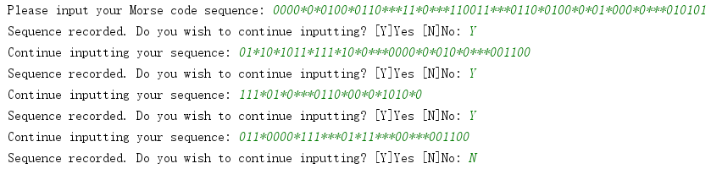

* It will display recorded sequences and decode sequences. As we can see, the sequence which doesn’t end with punctuation will return error and won’t be analysed in the next step:

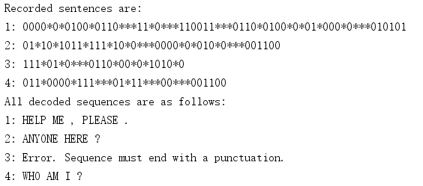

* In analysis section, users can select which level to analyse, or just display all analysis or quit:

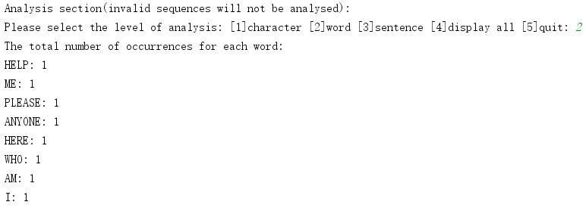

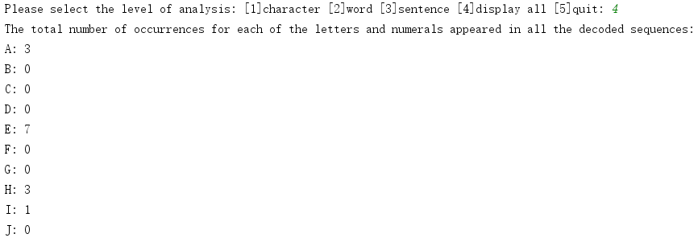

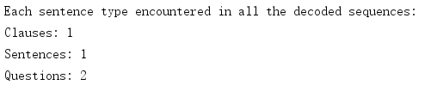

* The program will stop if user choose 5.

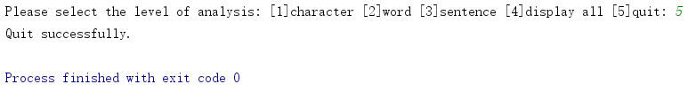

1. **Assumptions**

* In task1, I assume that users should input sequence that terminate with one punctuation from ‘.’; ‘,’ and ‘?’. If not or any invalid character detected, decode function will return an error massage, and set the Boolean variable is_valid to False.
* It’s ok that punctuations occur in the Morse code sequences (not in the end), but the last character must be a punctuation.
* In Morse code, punctuations and words should be separated by three ‘*’, which is a space after decoded.
* I assume that the user would insert a space before the last punctuation, and two spaces between the punctuation which is in the sentence.

1. **Limitations**

* For sentence analysis section, the ‘analyse_sentences’ function cannot analyse overly complex situations. The function counts the number of clauses by the occurrences of commas.
* In main function, it will display analysis for all sequences together from user input. It won’t display analysis for every single decoded sequence.
* All related python files need to be in the same directory so that the program can run correctly.